* fCopyright for test papers and marking guides remains with *West Australian Test Papers*.
* The papers may only be reproduced within the purchasing school according to the advertised conditions of sale.
* Test papers must be withdrawn after use and stored securely in the school until Friday November 30, 2018



**HUMAN BIOLOGY**

**Unit 1 and 2**

**2018**

Name: _______________________________________________________

Teacher: ___________________________________________________

**Time allowed for this paper**

Reading time before commencing work: ten minutes

Working time for the paper: three hours

**Materials required/recommended for this paper**

***To be provided by the supervisor:***

This Question/Answer Booklet

Multiple-choice Answer Sheet

***To be provided by the candidate:***

Standard items: pens (blue/black preferred), pencils (including coloured), sharpener, correction fluid/tape, eraser, ruler, highlighters

Special items: non-programmable calculators approved for use in this examination.

**Important note to candidates**

No other items may be taken into the examination room. It is **your** responsibility to ensure that you do not have any unauthorised material. If you have any unauthorised material with you, hand it to the supervisor **before** reading any further.

**Structure of this paper**

|  |  |  |  |  |  |
| --- | --- | --- | --- | --- | --- |
| Section | Number of questions available | Number of questions to be attempted | Suggested working time (minutes) | Marks available | Percentage of examination |
| Section One  Multiple-choice | 30 | 30 | 40 | 30 | 30 |
| Section Two  Short answers | 9 | 9 | 90 | 105 | 50 |
| Section Three  Extended answers | 3 | 2 | 50 | 40 | 20 |
|  |  |  |  | **Total** | 100 |

**Instructions to candidates**

1. The rules for the conduct of the Western Australian examinations are detailed in the *Year 12 Information Handbook 2018*. Sitting this examination implies that you agree to abide by these rules.

2. Answer the questions according to the following instructions.

Section One: Answer all questions on the separate Multiple-choice answer sheet provided. For each question, shade the box to indicate your answer. Use only a blue or black pen to shade the boxes. If you make a mistake, place a cross through that square, then shade your new answer. Do not erase or use correction fluid/tape. Marks will not be deducted for incorrect answers. No marks will be given if more than one answer is completed for any question.

Section Two: Write your answers in this Question/Answer booklet. Wherever possible, confine your answers to the line spaces provided.

Section Three: Consists of three questions. You must answer two questions. Tick the box next to the question you are answering. Write your answers in this Question/Answer booklet.

3. You must be careful to confine your answers to the specific questions asked and to follow any instructions that are specific to a particular question.

4. Supplementary pages for the use of planning/continuing your answer to a question have been provided at the end of this Question/Answer booklet. If you use these pages to continue an answer, indicate at the original answer where the answer is continued, i.e. give the page number.

**Section One: Multiple-choice 30% (30 Marks)**

This section has **30** questions. Answer **all** questions on the separate Multiple-choice Answer Sheet provided. For each question, shade the box to indicate your answer. Use only a blue or black pen to shade the boxes. If you make a mistake, place a cross through that square then shade your new answer. Do not erase or use correction fluid/tape. No marks will be given if more than one answer is completed for any question.

Suggested working time: 40 minutes.

1. Which of the following statements best describes the difference between random and systematic errors?
   1. Random errors are also known as human errors, whilst systematic errors are associated with the materials used.
   2. Random errors are predictable and can be avoided, whilst systematic errors are not predictable and therefore cannot be avoided.
   3. Random errors are based on the limitations of certain measurements, whilst systematic errors occur due to experimental design.
   4. Random errors require a change to the experimental method, whilst systematic errors can be reduced by taking averages.
2. Which of the following pairs best describes the definition of the associated nutrient?
   1. Lipids; main source of energy for cells
   2. Vitamins; can be broken down into fatty acids and glycerol
   3. Carbohydrates; broken down to amino acids and used as energy
   4. Minerals; can act as co-factors for enzymes in metabolism
3. Osteoporosis is a disease associated with the loss of bone mass. Doctors often prescribe
   1. Vitamin D, to assist in the absorption of calcium into bones.
   2. minimal exercise, to ensure patients do not break their bones.
   3. quitting smoking, to lower the amount of oestrogen in the body.
   4. biphosphanates, to increase the concentration of calcium in the blood.
4. When the cell is not dividing, the tangled network of DNA and proteins is known as
   1. chromatin.
   2. a chromosome.
   3. an epigenome.
   4. a nucleotide.
5. Upon falling pregnant, a couple choose to test the foetus for the Phenylketonuria (PKU) disorder. Which of the following would **not** be used to detect this genetic disease?
   1. Amniocentesis
   2. Chorionic Villus Sampling
   3. Fetoscopy
   4. Biochemical Analysis
6. Ventricular Septal Defect (VSD) is a common congenital disease of the heart associated with a hole in the septum between the two ventricle chambers.

Which of the following gives the best explanation as to why the concentration of oxygen leaving through the aorta would be low in someone with VSD?

* 1. Deoxygenated blood enters the right ventricle from the left ventricle
  2. Deoxygenated blood enters the left ventricle from the right ventricle
  3. Oxygenated blood enters the right ventricle from the left ventricle
  4. Oxygenated blood enters the left ventricle from the right ventricle

**Questions 7 and 8 refer to the diagram below.**

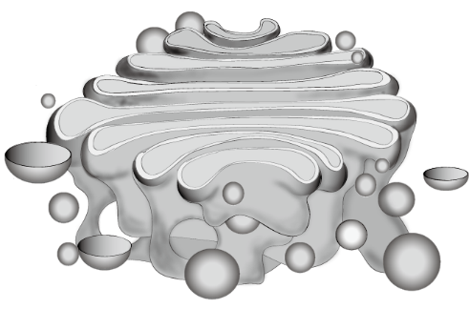

1. Where, in the cell, would you expect to find the cell organelle depicted above?
   1. Free in the cytoplasm
   2. Positioned near the nucleus
   3. As an extension of the nuclear membrane
   4. Attached to the cell membrane
2. The organelle above is associated with
3. modifying and packaging proteins.
4. cellular respiration.
5. digestion of large molecules.
6. storing and transferring molecules.

**Questions 9 and 10 refer to the table below that shows the percentage of 25 year olds with a sexually transmitted infection (STI) as compared to their alcohol consumption.**

|  |  |
| --- | --- |
| **Alcohol Consumption** | **Percentage (%)** |
| No Alcohol Consumption | 1.2 |
| Some Alcohol Use | 2.8 |
| Binge Drinking | 2.4 |
| Heavy Drinking | 3.1 |

1. What is the independent variable in this study?
2. Percentage of 25 year olds
3. Total number of 25 year olds with STI’s
4. Blood alcohol levels
5. Alcohol consumption
6. Which of the following is a conclusion that could be drawn from the data table above?
7. Young adult drinkers are at least twice as likely as non-drinkers to have an STI
8. 18-25 year olds that are heavy drinkers have less chance than non-drinkers to have an STI
9. Having an STI is more common in people using both alcohol and illicit drugs
10. Drinkers are 23% less likely to use a condom during sexual intercourse when they were drunk
11. Muscle tissue that is multinucleated and contains striations is best described as
12. involuntary muscle.
13. smooth muscle.
14. cardiac muscle.
15. skeletal muscle.
16. Methylation of DNA in humans would usually result in
17. mutations.
18. cell growth.
19. reduced levels of gene expression.
20. activation of gene expression.
21. Which of the following graphs best depicts the effect of substrate concentration on enzyme activity?
22. 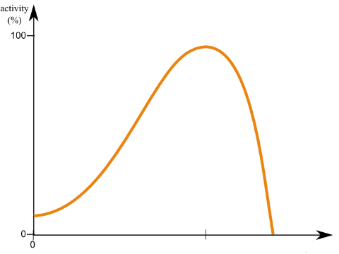 (b) 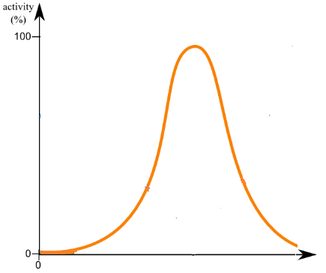

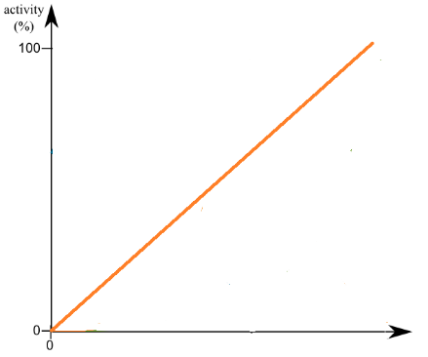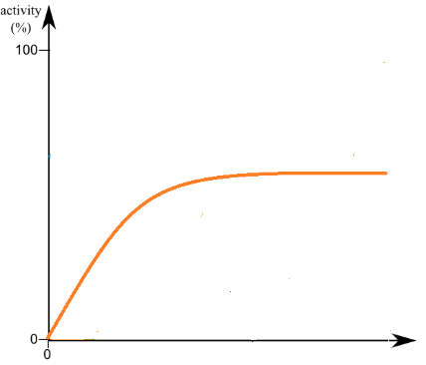

(c) (d)

1. The role of the bulbourethral (Cowper’s) gland in males is to secrete
2. mucus that acts as a lubricant.
3. thick mucus containing high levels of sugar.
4. milky mucus with a high pH level.
5. clear mucus that has a high acidity.
6. The name given to the cells of the testes which produce sperm is
7. seminiferous cells.
8. Sertoli cells.
9. Leydig cells.
10. sperm cells.
11. A pap smear is a recent technology that tests for
12. syphilis.
13. chlamydia.
14. genital warts.
15. cervical cancer.

**Questions 17 and 18 refer to the X-linked recessive pedigree below.**

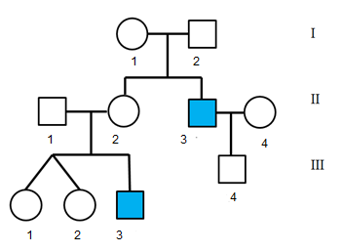

1. Individual III-3 bred with a female carrier and gave birth to a daughter. What is the probability of the daughter inheriting this trait?
2. 0%
3. 25%
4. 50%
5. 75%
6. An example of an X-linked recessive disease would be
7. Haemophilia.
8. Huntington’s disease.
9. Phenylketonuria (PKU).
10. Fragile X Syndrome.
11. The cells of a human have a diploid number of 46.

Which one of the following combinations best identifies the number of chromosomes in a heart cell, spermatozoa and a fertilised egg?

|  |  |  |  |
| --- | --- | --- | --- |
|  | Heart Cell | Spermatozoa | Fertilised Egg |
|  | 46 | 23 | 92 |
|  | 23 | 46 | 23 |
|  | 46 | 23 | 46 |
|  | 23 | 92 | 92 |

**Question 20 refers to the diagram below.**

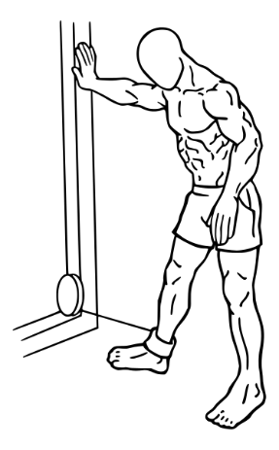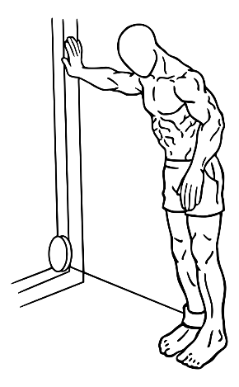

1. The movement depicted in the diagram above is best described as
2. flexion.
3. extension.
4. abduction.
5. adduction.
6. Which of the following sexually transmitted infections cannot be cured?
7. Herpes
8. Gonorrhoea
9. Syphilis
10. Trichomonas vaginalis
11. Ongoing exposure to asbestos fibres can increase the chances of a person developing
12. pneumonia.
13. asthma.
14. tuberculosis.
15. lung cancer.
16. ATP releases energy from its molecule when the bond between the
17. adenine and glucose is formed.
18. second and third phosphate is broken.
19. first and second phosphate is formed.
20. the adenine and ribose is broken.

**Question 24 refers to the diagram below.**

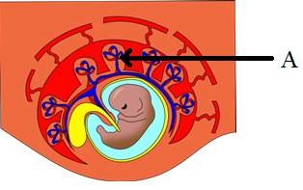

1. Once implanted, small finger-like projections, identified by the letter A, develop from the outer layer of cells of the blastocyst. These projections are known as
2. umbilical veins.
3. umbilical arteries.
4. chorionic villi.
5. amniotic sac.
6. The primary germ layer associated with the formation of the nervous system is
7. ectoderm.
8. endoderm.
9. mesoderm.
10. chorion.
11. The role of the gall bladder in the digestive system is to
12. produce bile that is deposited into the liver.
13. produce pancreatic juices that are deposited into the small intestine.
14. store and release bile into the small intestine.
15. store and release pancreatic juice into the pancreas.
16. Which of the following best identifies the process of deamination?
17. Amino Acid + Oxygen 🡪 Urea + Water
18. Carbon Dioxide + Amino Acid 🡪 Ammonia + Carbohydrate
19. Carbon Dioxide + Ammonia 🡪 Urea + Water
20. Amino Acid + Oxygen 🡪 Ammonia + Carbohydrate

**Question 28 refers to the diagram below, which shows a structure found within the human small intestine.**

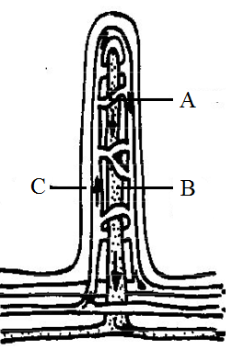

1. Which of the following statements is **incorrect**?
2. Short distance between structures A and C increases diffusion rate
3. Microvilli on structure C increases surface area
4. Glucose molecules move into C through diffusion and active transport
5. Structure B is part of the lymphatic system and is used to transport lipids
6. Which of the following terms best describes a teratogen?
7. A life-support system that aids in protecting the foetus
8. A chemical that stimulates the formation of organs
9. An environmental factor that causes birth defects
10. A substance that causes mutations
11. Although cell shape varies, all cells in the human body are small. The best explanation for this is that as the size of the cell increases
12. volume and surface area increases.
13. volume increases at a greater rate than the surface area.
14. surface area and volume increase.
15. surface area increases at a faster rate than the volume.

**Section Two: Short answer 50% (105 Marks)**

This section has **nine (9)** questions. Answer **all** questions. Write your answers in the spaces provided.

Supplementary pages for the use of planning/continuing your answer to a question have been provided at the end of this Question/Answer booklet. If you use these pages to continue an answer, indicate at the original answer where the answer is continued, i.e. give the page number.

Suggested working time: 90 minutes.

**Question 31 (15 marks)**

An investigation was undertaken to determine the effect of temperature on the ability of freshly activated sperm to fertilise freshly extracted eggs. 5 mL samples of eggs were added to a sperm suspension and, after 5 minutes, the eggs were removed and incubated. Samples were then viewed under 200X magnification, with 300 eggs counted and the proportion of 4+ cell embryos recorded.

Concurrently, three replicates of 1mL samples of sperm were incubated for 2 hours at the same temperatures and standardised to a concentration of 107 sperm/mL-1. Sperm samples were transferred to a microscope slide and videotaped under 200X magnification. The velocity of the sperm was calculated using the same motion analysis system.

The results from the investigation are shown below.

|  |  |  |  |  |  |  |
| --- | --- | --- | --- | --- | --- | --- |
| **Temperature (℃)** | **15** | **20** | **25** | **30** | **35** | **40** |
| **Fertilisation Success (%)** | 19.4 | 21.6 | 58.5 | 87.2 | 39.4 | 23.6 |
| **Sperm Velocity (µm/sec-1)** | 45 | 50 | 89 | 150 | 45 | 38 |

1. Graph these results on the grid provided below.

(6 marks)

A spare grid can be found on page 42.

|  |  |  |  |  |  |  |  |  |  |  |  |  |
| --- | --- | --- | --- | --- | --- | --- | --- | --- | --- | --- | --- | --- |
|  |  |  |  |  |  |  |  |  |  |  |  |  |
|  |  |  |  |  |  |  |  |  |  |  |  |  |
|  |  |  |  |  |  |  |  |  |  |  |  |  |
|  |  |  |  |  |  |  |  |  |  |  |  |  |
|  |  |  |  |  |  |  |  |  |  |  |  |  |
|  |  |  |  |  |  |  |  |  |  |  |  |  |
|  |  |  |  |  |  |  |  |  |  |  |  |  |
|  |  |  |  |  |  |  |  |  |  |  |  |  |
|  |  |  |  |  |  |  |  |  |  |  |  |  |
|  |  |  |  |  |  |  |  |  |  |  |  |  |
|  |  |  |  |  |  |  |  |  |  |  |  |  |
|  |  |  |  |  |  |  |  |  |  |  |  |  |
|  |  |  |  |  |  |  |  |  |  |  |  |  |
|  |  |  |  |  |  |  |  |  |  |  |  |  |

1. Identify **two** variables **not** indicated in the information for the fertilisation success investigation that needed to be maintained across all temperatures to ensure a fair test was conducted. (2 marks)

___________________________________________________________________

___________________________________________________________________

___________________________________________________________________

1. For **one** of the variables identified in part (b), state why it needed to be controlled.

(1 mark)

___________________________________________________________________

___________________________________________________________________

___________________________________________________________________

1. Suggest what may have caused the observed effect of increased fertilisation success. (3 marks)

___________________________________________________________________

___________________________________________________________________

___________________________________________________________________

___________________________________________________________________

___________________________________________________________________

___________________________________________________________________

1. Explain what may have caused the drastic drop in sperm velocity after 30℃. (3 marks)

___________________________________________________________________

___________________________________________________________________

___________________________________________________________________

___________________________________________________________________

___________________________________________________________________

___________________________________________________________________

**Question 32 (10 marks)**

A married couple, intending on starting their own family, were advised to attend a local genetic counselling clinic to discuss the risks of producing offspring with phenylketonuria (PKU), which is present in the mother’s family.

1. Suggest an explanation the genetic counsellor may have given to explain the relationship between genes and chromosomes. (2 marks)

___________________________________________________________________

___________________________________________________________________

___________________________________________________________________

___________________________________________________________________

1. Suggest a reason as to why the genetic counsellor would create a pedigree chart for this disease. (1 mark)

___________________________________________________________________

___________________________________________________________________

Upon receiving this advice, the couple then attended a fertility clinic to get information on how to increase their chances of pregnancy. The clinician described the structure and function of the human reproductive system, and explained the reproductive cycles.

1. State the differences between the female and male gametes concerning their size, structure and relative number. (3 marks)

___________________________________________________________________

___________________________________________________________________

___________________________________________________________________

___________________________________________________________________

___________________________________________________________________

___________________________________________________________________

1. Describe one factor that the couple could monitor that could be used to increase the couple’s chances of falling pregnant. (2 marks)

___________________________________________________________________

___________________________________________________________________

___________________________________________________________________

___________________________________________________________________

1. (i) Unfortunately the couple struggled to fall pregnant. Identify **one** Assisted

Reproductive Technology (ART) that the couple could use.

(1 mark)

________________________________________________________________

(ii) State **one** common complication associated with the ART identified in part (e)(i) above.

(1 mark)

________________________________________________________________________________________________________________________________

**Question 33 (12 marks)**

For many hundreds of years, experiments with blood transfusions have been undertaken. However, it was in 1901, when Karl Landsteiner discovered human blood groups, that they became safer.

1. State **one** disease that would require a blood transfusion.

(1 mark)

___________________________________________________________________

1. Explain why it is important to determine the blood groups of both the recipient and donor in blood transfusions. (4 marks)

___________________________________________________________________

___________________________________________________________________

___________________________________________________________________

___________________________________________________________________

___________________________________________________________________

___________________________________________________________________

___________________________________________________________________

___________________________________________________________________

1. Describe how ABO blood groups are inherited. (3 marks)

___________________________________________________________________

___________________________________________________________________

___________________________________________________________________

___________________________________________________________________

___________________________________________________________________

___________________________________________________________________

1. Using a Punnett square, explain if it is possible for an O-type child to be born to a B-type father and AB-type mother. (4 marks)

___________________________________________________________________

___________________________________________________________________

___________________________________________________________________

___________________________________________________________________

___________________________________________________________________

___________________________________________________________________

___________________________________________________________________

___________________________________________________________________

**Question 34 (12 marks)**

1. Muscles work in pairs to provide the skeletal system with motion. Explain why synergists are important in producing movement. (3 marks)

___________________________________________________________________

___________________________________________________________________

___________________________________________________________________

___________________________________________________________________

___________________________________________________________________

___________________________________________________________________

The diagrams below show one sarcomere in its fully relaxed state and when it is contracted fully.

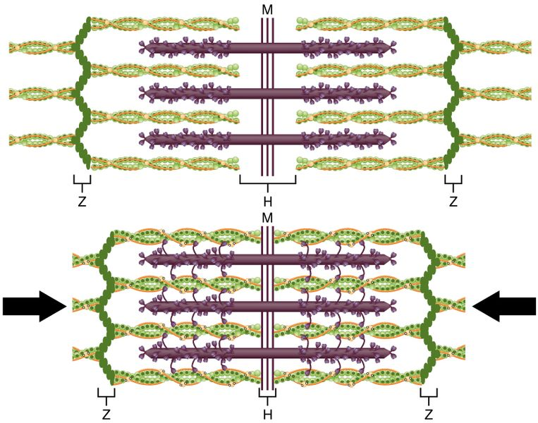

1. When a sarcomere contracts, the myosin filaments pull the actin filaments towards the M-line. Explain how this movement occurs. (4 marks)

___________________________________________________________________

___________________________________________________________________

___________________________________________________________________

___________________________________________________________________

___________________________________________________________________

___________________________________________________________________

1. There are two types of bone found in the human body. Name these types of bone and describe **two** structural differences between the two.

(4 marks)

___________________________________________________________________

___________________________________________________________________

___________________________________________________________________

___________________________________________________________________

___________________________________________________________________

___________________________________________________________________

___________________________________________________________________

___________________________________________________________________

1. Suggest why a ball-and-socket joint at the knee would create problems for upright walking. (1 mark)

___________________________________________________________________

___________________________________________________________________

**Question 35 (12 marks)**

1. The Atkins Diet is based on high protein foods.
2. Briefly describe what happens to these proteins after the food reaches the stomach and then enters the small intestine. (4 marks)

________________________________________________________________________________________________________________________________________________________________________________________________________________________________________________________________________________________________________________________________________________________________________________________________________________________________________________________________________________________________________________________________

1. State the name given to the type of digestion that would have occurred in the mouth prior to swallowing. (1 mark)

________________________________________________________________

1. Suggest a reason why high protein diets are recommended for weight loss.

(1 mark)

________________________________________________________________________________________________________________________________

1. Type 1 Diabetes is a genetic disorder that inhibits an individual from taking up glucose into their cells. Blood glucose monitoring is therefore very important for individuals with Type 1 Diabetes.
2. A glucose biosensor uses the enzyme glucose oxidase. Using your understanding of enzymes, briefly explain why the biosensor is specific for glucose. (2 marks)

________________________________________________________________________________________________________________________________________________________________________________________________________________________________________________________________

1. State the names and locations of the steps involved in the complete breakdown of glucose within the cell. (3 marks)

________________________________________________________________________________________________________________________________________________________________________________________________________________________________________________________________________________________________________________________________________________________________________________________________

1. Identify **one** product that differs between aerobic and anaerobic respiration in human cells. (1 mark)

________________________________________________________________

**Question 36 (8 marks)**

An investigation on the effect of physical activity on respiration rate was undertaken. Immediately after completing an activity, each individual breathed into a container of pH indicator solution. The time it took for the pH indicator to change from blue to red was recorded.

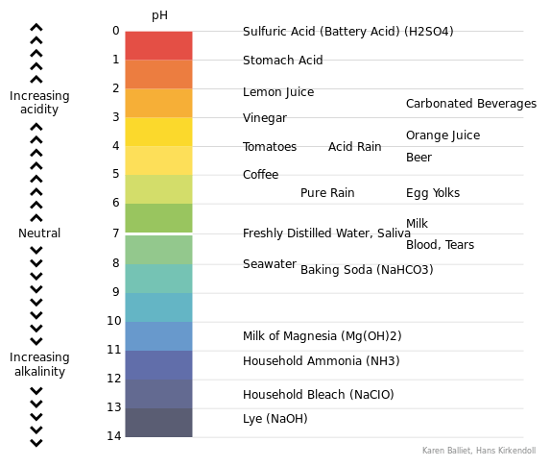

Purple Dark Blue Blue Green Yellow Orange Red

1. Identify the gas that would have been present in larger amounts after the activity, and explain why its presence would have caused the change in colour. (2 marks)

________________________________________________________________________________________________________________________________________________________________________________________________________________________________________________________________

Whilst performing one of the activities, one of the individuals fell over and cut their knee.

1. (i) State which two formed elements of the blood would expect to

increase in concentration following this injury, and explain why this would have occurred. (4 marks)

________________________________________________________________________________________________________________________________________________________________________________________________________________________________________________________________________________________________________________________________________________________________________________________________________________________________________________________________________________________________________________________________

(ii) Name and describe the type of tissue that blood is categorised as. (2 marks)

________________________________________________________________________________________________________________________________________________________________________________________________________________________________________________________________

**Question 37 (11 marks)**

1. The following diagrams represent a selection of the five (5) different stages of mitosis.

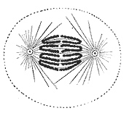 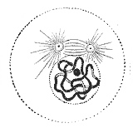 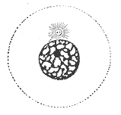

A B C

1. List the diagrams (A, B, C) in the correct order for the process of mitosis. (1 mark)

________________________________________________________________

1. Identify the missing stages and draw diagrams to show what would be occurring in each of the missing stages. (4 marks)
2. During the synthesis stage of mitosis, the DNA within a cell is replicated to allow for the production of identical daughter cells.

State the role of the following enzymes in the process of DNA replication.

(3 marks)

1. Helicase

____________________________________________________________________________________________________________________________

1. DNA Polymerase

____________________________________________________________________________________________________________________________

1. DNA Ligase ____________________________________________________________________________________________________________________________

Occasionally cells can become abnormal, invading and damaging the tissues of the body. These diseases can be diagnosed as cancer.

1. Describe how cancer develops and suggest one way it can spread throughout the body (metastasise). (3 marks)

__________________________________________________________________________________________________________________________________________________________________________________________________________________________________________________________________________________________________________________________________________________________________________________________________________________

**Question 38 (13 marks)**

1. A sample of tissue was extracted from a crime scene. DNA profiling was undertaken and the respective banding patterns produced. These are shown in the diagram below.

|  |  |  |  |  |  |  |
| --- | --- | --- | --- | --- | --- | --- |
|  |  |  |  |  |  |  |
|  |  |  |  |  |  |  |
|  |  |  |  |  |  |  |
|  |  |  |  |  |  |  |
|  |  |  |  |  |  |  |
|  |  |  |  |  |  |  |
|  |  |  |  |  |  |  |
| Victim |  | Suspect 1 |  | Sample |  | Suspect 2 |

1. Identify which suspect was most likely the perpetrator of this crime.

(1 mark)

________________________________________________________________

1. Explain how you arrived at your answer in part (a)(i). (1 mark)

________________________________________________________________________________________________________________________________

DNA profiling utilises the biotechnology of Polymerase Chain Reaction (PCR). PCR mimics the steps of DNA replication.

1. Identify **three** structural properties of DNA that allow it to be replicated.

(3 marks)

__________________________________________________________________________________________________________________________________________________________________________________________________________________________________________________________________________________________________________________________________________________________________________________________________________________

1. DNA profiling can also be used for the screening of embryonic stem cells. Discuss an ethical issue that may arise in stem cell research for people with religious beliefs.

(2 marks)

____________________________________________________________________________________________________________________________________________________________________________________________________________________________________________________________________________

1. Where are embryonic stem cells harvested from? (2 marks)

______________________________________________________________________________________________________________________________________

Below is a pedigree of a human skin disease that was created by using the information attained from DNA profiling of a family.

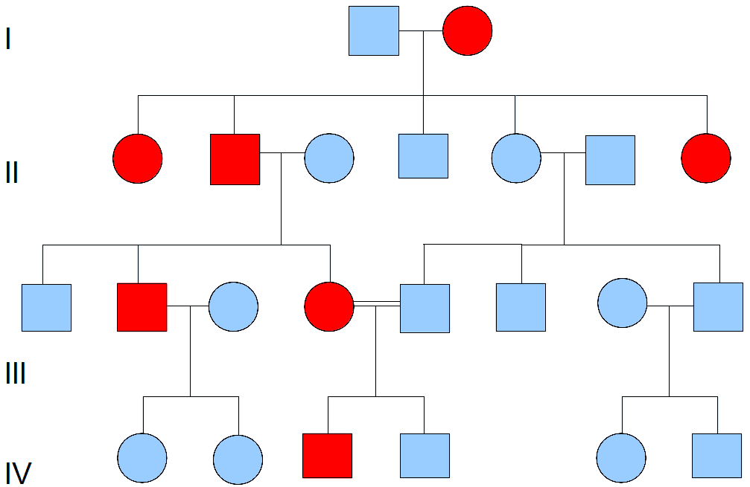

1. (i) Identify the relationship identified by the double horizontal lines connecting

individuals III-4 and III-5. (1 mark)

________________________________________________________________

(ii) Is this disease X-linked or Autosomal? Use individual III-2 to justify your answer. (3 marks)

________________________________________________________________________________________________________________________________________________________________________________________________________________________________________________________________________________________________________________________________________________________________________________________________

**Question 39 (12 marks)**

The female reproductive system is designed to both produce gametes and provide for the development of an embryo and foetus. The diagram below shows the external female genitalia.

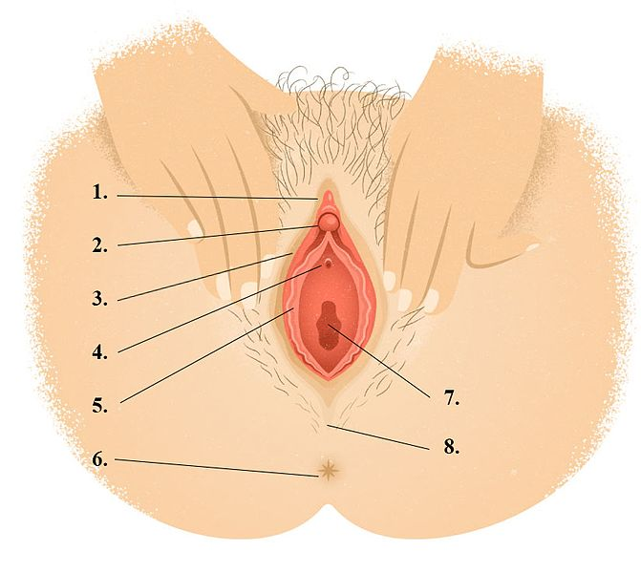

1. Identify the organs identified at position: (2 marks)

2: ___________________________________________

5: ___________________________________________

1. State **one** function of the organ labelled by the number 7. (1 mark)

______________________________________________________________________________________________________________________________________

1. In 90% of births, the foetus’s head is facing downward. Describe **one** reason why it is better for the foetus to be in this position. (2 marks)

____________________________________________________________________________________________________________________________________________________________________________________________________________________________________________________________________________

1. Explain why a large number of sperm are required for fertilisation.

(3 marks)

__________________________________________________________________________________________________________________________________________________________________________________________________________________________________________________________________________________________________________________________________________________________________________________________________________________

1. Describe **one** hormonal contraception method for women that could be used to prevent fertilisation. Identify **one** risk and **one** benefit of this method as a contraceptive. (4 marks)

________________________________________________________________________________________________________________________________________________________________________________________________________________________________________________________________________________________________________________________________________________________________________________________________________________________________________________________________________________________________________________________________________________________

**Section Three: Extended answer 20% (40 Marks)**

This section has **three (3)** questions. You must answer **two (2)** questions. Write your answers on the lined pages provided.

Supplementary pages for the use of planning/continuing your answer to a question have been provided at the end of this Question/Answer booklet. If you use these pages to continue an answer, indicate at the original answer where the answer is continued, i.e. give the page number.

Responses could include clearly labelled diagrams with explanatory notes; lists of points with linking sentences; clearly labelled tables and graphs; and annotated flow diagrams with introductory notes.

Suggested working time: 50 minutes.

Answer any **two (2)** questions from Questions 40 to 42.

Indicate the questions you will answer by ticking the box next to the question. Write your answers on the pages that follow.

**Question 40 (20 marks)**

1. Hormones released from the pituitary gland and ovaries regulate the menstrual and ovarian cycles. State the name of **two** of these hormones and describe the effect they have on the reproductive cycles.

(6 marks)

1. Prolactin, a lactogenic hormone, is a protein that has a direct effect on the breasts of pregnant women to produce and maintain milk.

Describe the process of protein synthesis that would result in the production of the hormone prolactin. (14 marks)

**Question 41 (20 marks)**

1. The probability of any one person being born has been calculated to be approximately 1 in 400,000,000,000. Explain how the genetic (DNA) variation seen in humans can arise due to meiosis and reproduction. (8 marks)
2. Explain how the lungs are specifically structured and function to ensure that cells are constantly supplied with oxygen and have their waste product, carbon dioxide, removed. (12 marks)

**Question 42 (20 marks)**

1. For the cells of a body to function normally, they must remain in a stable environment. Describe the structure of the cell membrane and explain how it allows the exchange of ions to occur. (14 marks)
2. Some chemical processes occurring in the body produce toxic waste products, such as urea. The excretory system is involved in removing metabolic wastes. Briefly describe the main processes involved for the kidneys to produce urine. (6 marks)

Question number: ________________

__________________________________________________________________________________________________________________________________________________

_________________________________________________________________________

_________________________________________________________________________

_________________________________________________________________________

_________________________________________________________________________

__________________________________________________________________________________________________________________________________________________

_________________________________________________________________________

_________________________________________________________________________

_________________________________________________________________________

_________________________________________________________________________

__________________________________________________________________________________________________________________________________________________

_________________________________________________________________________

_________________________________________________________________________

_________________________________________________________________________

_________________________________________________________________________

__________________________________________________________________________________________________________________________________________________

_________________________________________________________________________

_________________________________________________________________________

_________________________________________________________________________

_________________________________________________________________________

__________________________________________________________________________________________________________________________________________________

Question number: ________________

__________________________________________________________________________________________________________________________________________________

_________________________________________________________________________

_________________________________________________________________________

_________________________________________________________________________

_________________________________________________________________________

__________________________________________________________________________________________________________________________________________________

_________________________________________________________________________

_________________________________________________________________________

_________________________________________________________________________

_________________________________________________________________________

__________________________________________________________________________________________________________________________________________________

_________________________________________________________________________

_________________________________________________________________________

_________________________________________________________________________

_________________________________________________________________________

__________________________________________________________________________________________________________________________________________________

_________________________________________________________________________

_________________________________________________________________________

_________________________________________________________________________

_________________________________________________________________________

__________________________________________________________________________________________________________________________________________________

_________________________________________________________________________

Question number: ________________

__________________________________________________________________________________________________________________________________________________

_________________________________________________________________________

_________________________________________________________________________

_________________________________________________________________________

_________________________________________________________________________

__________________________________________________________________________________________________________________________________________________

_________________________________________________________________________

_________________________________________________________________________

_________________________________________________________________________

_________________________________________________________________________

__________________________________________________________________________________________________________________________________________________

_________________________________________________________________________

_________________________________________________________________________

_________________________________________________________________________

_________________________________________________________________________

__________________________________________________________________________________________________________________________________________________

_________________________________________________________________________

_________________________________________________________________________

_________________________________________________________________________

_________________________________________________________________________

__________________________________________________________________________________________________________________________________________________

_________________________________________________________________________

Question number: ________________

__________________________________________________________________________________________________________________________________________________

_________________________________________________________________________

_________________________________________________________________________

_________________________________________________________________________

_________________________________________________________________________

__________________________________________________________________________________________________________________________________________________

_________________________________________________________________________

_________________________________________________________________________

_________________________________________________________________________

_________________________________________________________________________

__________________________________________________________________________________________________________________________________________________

_________________________________________________________________________

_________________________________________________________________________

_________________________________________________________________________

_________________________________________________________________________

__________________________________________________________________________________________________________________________________________________

_________________________________________________________________________

_________________________________________________________________________

_________________________________________________________________________

_________________________________________________________________________

__________________________________________________________________________________________________________________________________________________

_________________________________________________________________________

Question number: ________________

__________________________________________________________________________________________________________________________________________________

_________________________________________________________________________

_________________________________________________________________________

_________________________________________________________________________

_________________________________________________________________________

__________________________________________________________________________________________________________________________________________________

_________________________________________________________________________

_________________________________________________________________________

_________________________________________________________________________

_________________________________________________________________________

__________________________________________________________________________________________________________________________________________________

_________________________________________________________________________

_________________________________________________________________________

_________________________________________________________________________

_________________________________________________________________________

__________________________________________________________________________________________________________________________________________________

_________________________________________________________________________

_________________________________________________________________________

_________________________________________________________________________

_________________________________________________________________________

__________________________________________________________________________________________________________________________________________________

_________________________________________________________________________

Question number: ________________

__________________________________________________________________________________________________________________________________________________

_________________________________________________________________________

_________________________________________________________________________

_________________________________________________________________________

_________________________________________________________________________

__________________________________________________________________________________________________________________________________________________

_________________________________________________________________________

_________________________________________________________________________

_________________________________________________________________________

_________________________________________________________________________

__________________________________________________________________________________________________________________________________________________

_________________________________________________________________________

_________________________________________________________________________

_________________________________________________________________________

_________________________________________________________________________

__________________________________________________________________________________________________________________________________________________

_________________________________________________________________________

_________________________________________________________________________

_________________________________________________________________________

_________________________________________________________________________

__________________________________________________________________________________________________________________________________________________

_________________________________________________________________________

Question number: ________________

__________________________________________________________________________________________________________________________________________________

_________________________________________________________________________

_________________________________________________________________________

_________________________________________________________________________

_________________________________________________________________________

__________________________________________________________________________________________________________________________________________________

_________________________________________________________________________

_________________________________________________________________________

_________________________________________________________________________

_________________________________________________________________________

__________________________________________________________________________________________________________________________________________________

_________________________________________________________________________

_________________________________________________________________________

_________________________________________________________________________

_________________________________________________________________________

__________________________________________________________________________________________________________________________________________________

_________________________________________________________________________

_________________________________________________________________________

_________________________________________________________________________

_________________________________________________________________________

__________________________________________________________________________________________________________________________________________________

_________________________________________________________________________

Additional Working

__________________________________________________________________________________________________________________________________________________

_________________________________________________________________________

_________________________________________________________________________

_________________________________________________________________________

_________________________________________________________________________

__________________________________________________________________________________________________________________________________________________

_________________________________________________________________________

_________________________________________________________________________

_________________________________________________________________________

_________________________________________________________________________

__________________________________________________________________________________________________________________________________________________

_________________________________________________________________________

_________________________________________________________________________

_________________________________________________________________________

_________________________________________________________________________

__________________________________________________________________________________________________________________________________________________

_________________________________________________________________________

_________________________________________________________________________

_________________________________________________________________________

_________________________________________________________________________

__________________________________________________________________________________________________________________________________________________

_________________________________________________________________________

Additional Working

__________________________________________________________________________________________________________________________________________________

_________________________________________________________________________

_________________________________________________________________________

_________________________________________________________________________

_________________________________________________________________________

__________________________________________________________________________________________________________________________________________________

_________________________________________________________________________

_________________________________________________________________________

_________________________________________________________________________

_________________________________________________________________________

__________________________________________________________________________________________________________________________________________________

_________________________________________________________________________

_________________________________________________________________________

_________________________________________________________________________

_________________________________________________________________________

__________________________________________________________________________________________________________________________________________________

_________________________________________________________________________

_________________________________________________________________________

_________________________________________________________________________

_________________________________________________________________________

__________________________________________________________________________________________________________________________________________________

_________________________________________________________________________

Spare Grid

|  |  |  |  |  |  |  |  |  |  |  |  |  |
| --- | --- | --- | --- | --- | --- | --- | --- | --- | --- | --- | --- | --- |
|  |  |  |  |  |  |  |  |  |  |  |  |  |
|  |  |  |  |  |  |  |  |  |  |  |  |  |
|  |  |  |  |  |  |  |  |  |  |  |  |  |
|  |  |  |  |  |  |  |  |  |  |  |  |  |
|  |  |  |  |  |  |  |  |  |  |  |  |  |
|  |  |  |  |  |  |  |  |  |  |  |  |  |
|  |  |  |  |  |  |  |  |  |  |  |  |  |
|  |  |  |  |  |  |  |  |  |  |  |  |  |
|  |  |  |  |  |  |  |  |  |  |  |  |  |
|  |  |  |  |  |  |  |  |  |  |  |  |  |
|  |  |  |  |  |  |  |  |  |  |  |  |  |
|  |  |  |  |  |  |  |  |  |  |  |  |  |
|  |  |  |  |  |  |  |  |  |  |  |  |  |
|  |  |  |  |  |  |  |  |  |  |  |  |  |

**ACKNOWLEDGMENTS**

**Question 7-8** DataBase Center for Life Science (DBCLS) [Generalised Cell Organelle Image]. (n.d.) Retrieved November, 2017, from: https://commons.wikimedia.org/wiki/File%3A201601[...]

**Question 13** Adapted from: Gal m (Own work). (2007) Graph of Enzyme Activity [Image]. Retrieved November, 2017, from: https://commons.wikimedia.org/wiki/File%3AEnzyme-ph.png

**Question 17-18** Adapted from:山口大輔. (2009). Pedigree Chart [Image]. Retrieved Novmeber, 2017, from: https://commons.wikimedia.org/wiki/File%3APedigree.png

**Question 20** Everkinetic. (2010) Hip Movement [Images]. Retrieved November, 2017, from: https://commons.wikimedia.org/w/index.php?curid=47435431 and

[https://upload.wikimedia.org/wikipedia/commons/8/89/[...].png](https://upload.wikimedia.org/wikipedia/commons/8/89/%5b...%5d.png)

**Question 24** Sheldahl. (2016) Unlabeled cartoon of human neurula stage embryo [Image]. Retrieved November, 2017, from: <https://commons.wikimedia.org/wiki/File%3ANeurula_human.png>

**Question 28** Sunshineconnelly at English Wikibooks. (2007). Wall of Small Intestine. Retrieved November, 2017, from: https://commons.wikimedia.org/wiki/File%3AAnatomy_and_physiology_of_animals_Wall_of_small_intestine_showing_[...].jpg

**Question 34(b)** OpenStax. (2016). Sliding Filament Model [Image]. Retrieved November, 2017, from: <https://commons.wikimedia.org/wiki/File%3A1006_Sliding_Filament_Model_of_Muscle_Contraction.jpg>

**Question 36(a)** Hans Kirkendoll. (2009). Power of Hydrogen (pH) chart [Image]. Retrieved November, 2017 from:

<https://commons.wikimedia.org/wiki/File%3APower_of_Hydrogen_(pH)_chart.svg>

**Question 37(a)** Henry Gray’s Anatomy of the Human Body. (n.d.) [Generalised Mitosis Stages]. Retrieved November, 2017, from: The original uploader was D. Wu at English Wikipedia (Transferred from en.wikipedia to Commons.) [Public domain or Public domain], via Wikimedia Commons

**Question 38(e)** Caulton, S. (2013). Pedigree chart of the inheritance of an […] [Image]. Retrieved December, 2017, from: https://commons.wikimedia.org/wiki/File:[...].png

**Question 39(a)(b)** Fyrstinnen. (2017). Female Genitalia [Image]. Retrieved November, 2017, from: [https://commons.wikimedia.org/wiki/File%3A[...].jpg](https://commons.wikimedia.org/wiki/File%3A%5b...%5d.jpg)